**Question 1**

Use Batch, Mini-Batch and Stochastic Gradient Descent to train a model on the Iris dataset

**Source Code**

**Batch Gradient Descent**  
import pandas as pd

import numpy as np

from sklearn.model_selection import train_test_split

from sklearn.metrics import mean_absolute_error, mean_squared_error, r2_score

dataset_url = "https://archive.ics.uci.edu/ml/machine-learning-databases/iris/iris.data"

columns = ['sepal_length', 'sepal_width', 'petal_length', 'petal_width', 'class']

data = pd.read_csv(dataset_url, header=None, names=columns)

print("Dataset Preview:")

print(data.head())

X = data[['sepal_length', 'sepal_width', 'petal_width']].values

y = data['petal_length'].values.reshape(-1, 1)

X = np.hstack([np.ones((X.shape[0], 1)), X])

X_train, X_test, y_train, y_test = train_test_split(X, y, test_size=0.2, random_state=42)

n_features = X_train.shape[1]

theta = np.zeros((n_features, 1))

learning_rate = 0.01

epochs = 1000

m = len(y_train) # Number of training samples

for epoch in range(epochs):

predictions = np.dot(X_train, theta)

error = predictions - y_train

gradient = (1 / m) * np.dot(X_train.T, error)

theta -= learning_rate * gradient

y_pred = np.dot(X_test, theta)

mae = mean_absolute_error(y_test, y_pred)

mse = mean_squared_error(y_test, y_pred)

rmse = np.sqrt(mse)

r2 = r2_score(y_test, y_pred)

print("\nEvaluation Metrics:")

print(f"Mean Absolute Error (MAE): {mae:.4f}")

print(f"Mean Squared Error (MSE): {mse:.4f}")

print(f"Root Mean Squared Error (RMSE): {rmse:.4f}")

print(f"R-squared (R²): {r2:.4f}")

**Output**

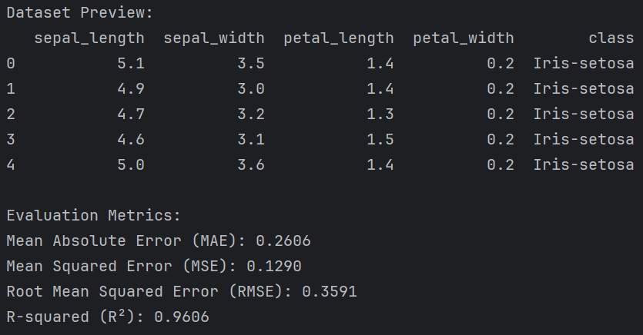*Terminal*

**Mini-Batch Gradient Descent**  
import pandas as pd

import numpy as np

from sklearn.model_selection import train_test_split

from sklearn.metrics import mean_absolute_error, mean_squared_error, r2_score

dataset_url = "https://archive.ics.uci.edu/ml/machine-learning-databases/iris/iris.data"

columns = ['sepal_length', 'sepal_width', 'petal_length', 'petal_width', 'class']

data = pd.read_csv(dataset_url, header=None, names=columns)

print("Dataset Preview:")

print(data.head())

X = data[['sepal_length', 'sepal_width', 'petal_width']].values

y = data['petal_length'].values.reshape(-1, 1)

X = np.hstack([np.ones((X.shape[0], 1)), X])

X_train, X_test, y_train, y_test = train_test_split(X, y, test_size=0.2, random_state=42)

n_features = X_train.shape[1]

theta = np.zeros((n_features, 1))

learning_rate = 0.01

epochs = 1000

batch_size = 16

# Mini-Batch Gradient Descent

m = len(y_train)

for epoch in range(epochs):

shuffled_indices = np.random.permutation(m)

X_train_shuffled = X_train[shuffled_indices]

y_train_shuffled = y_train[shuffled_indices]

for i in range(0, m, batch_size):

X_batch = X_train_shuffled[i:i + batch_size]

y_batch = y_train_shuffled[i:i + batch_size]

predictions = np.dot(X_batch, theta)

error = predictions - y_batch

gradient = (1 / batch_size) * np.dot(X_batch.T, error)

theta -= learning_rate * gradient

y_pred = np.dot(X_test, theta)

mae = mean_absolute_error(y_test, y_pred)

mse = mean_squared_error(y_test, y_pred)

rmse = np.sqrt(mse)

r2 = r2_score(y_test, y_pred)

print("\nEvaluation Metrics:")

print(f"Mean Absolute Error (MAE): {mae:.4f}")

print(f"Mean Squared Error (MSE): {mse:.4f}")

print(f"Root Mean Squared Error (RMSE): {rmse:.4f}")

print(f"R-squared (R²): {r2:.4f}")

**Output**

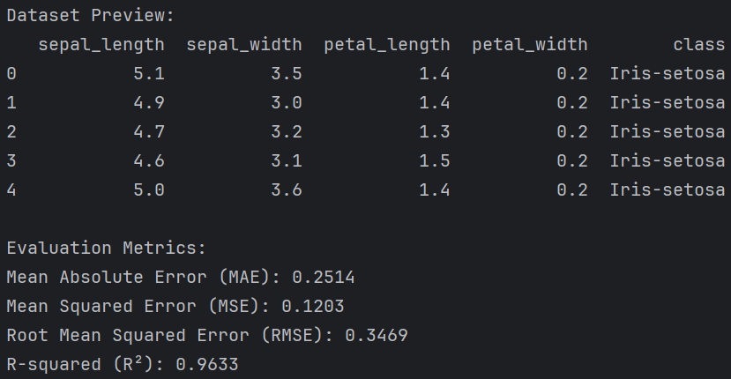*Terminal*

**Stochastic Gradient Descent**  
import pandas as pd

import numpy as np

from sklearn.model_selection import train_test_split

from sklearn.metrics import mean_absolute_error, mean_squared_error, r2_score

dataset_url = "https://archive.ics.uci.edu/ml/machine-learning-databases/iris/iris.data"

columns = ['sepal_length', 'sepal_width', 'petal_length', 'petal_width', 'class']

data = pd.read_csv(dataset_url, header=None, names=columns)

print("Dataset Preview:")

print(data.head())

X = data[['sepal_length', 'sepal_width', 'petal_width']].values

y = data['petal_length'].values.reshape(-1, 1)

X = np.hstack([np.ones((X.shape[0], 1)), X])

X_train, X_test, y_train, y_test = train_test_split(X, y, test_size=0.2, random_state=42)

n_features = X_train.shape[1]

theta = np.zeros((n_features, 1))

learning_rate = 0.01

epochs = 1000

m = len(y_train)

for epoch in range(epochs):

for i in range(m):

random_index = np.random.randint(0, m)

x_i = X_train[random_index:random_index + 1]

y_i = y_train[random_index:random_index + 1]

prediction = np.dot(x_i, theta)

error = prediction - y_i

gradient = x_i.T * error

theta -= learning_rate * gradient

y_pred = np.dot(X_test, theta)

mae = mean_absolute_error(y_test, y_pred)

mse = mean_squared_error(y_test, y_pred)

rmse = np.sqrt(mse)

r2 = r2_score(y_test, y_pred)

print("\nEvaluation Metrics:")

print(f"Mean Absolute Error (MAE): {mae:.4f}")

print(f"Mean Squared Error (MSE): {mse:.4f}")

print(f"Root Mean Squared Error (RMSE): {rmse:.4f}")

print(f"R-squared (R²): {r2:.4f}")

**Output**

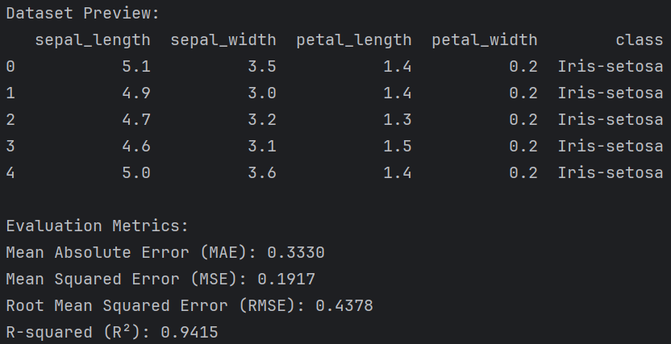*Terminal*

**Question 2**

Use Batch, Mini-Batch and Stochastic Gradient Descent to train a model on the Diabetes dataset.

**Source Code**

**Batch Gradient Descent**  
import numpy as np

from sklearn.datasets import load_diabetes

from sklearn.model_selection import train_test_split

from sklearn.metrics import mean_absolute_error, mean_squared_error, r2_score

diabetes = load_diabetes()

X = diabetes.data

y = diabetes.target.reshape(-1, 1)

print("Dataset Preview:")

print(diabetes)

X = np.hstack([np.ones((X.shape[0], 1)), X])

X_train, X_test, y_train, y_test = train_test_split(X, y, test_size=0.2, random_state=42)

n_features = X_train.shape[1]

theta = np.zeros((n_features, 1))

learning_rate = 0.01

epochs = 1000

m = len(y_train)

for epoch in range(epochs):

predictions = np.dot(X_train, theta)

error = predictions - y_train

gradient = (1 / m) * np.dot(X_train.T, error)

theta -= learning_rate * gradient

y_pred = np.dot(X_test, theta)

mae = mean_absolute_error(y_test, y_pred)

mse = mean_squared_error(y_test, y_pred)

rmse = np.sqrt(mse)

r2 = r2_score(y_test, y_pred)

print("\nEvaluation Metrics:")

print(f"Mean Absolute Error (MAE): {mae:.4f}")

print(f"Mean Squared Error (MSE): {mse:.4f}")

print(f"Root Mean Squared Error (RMSE): {rmse:.4f}")

print(f"R-squared (R²): {r2:.4f}")

**Output**

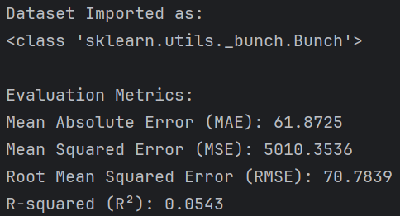*Terminal*

**Mini-Batch Gradient Descent**  
import numpy as np

from sklearn.datasets import load_diabetes

from sklearn.model_selection import train_test_split

from sklearn.metrics import mean_absolute_error, mean_squared_error, r2_score

diabetes = load_diabetes()

X = diabetes.data

y = diabetes.target.reshape(-1, 1)

print("Dataset Imported as:")

print(type(diabetes))

X = np.hstack([np.ones((X.shape[0], 1)), X])

X_train, X_test, y_train, y_test = train_test_split(X, y, test_size=0.2, random_state=42)

n_features = X_train.shape[1]

theta = np.zeros((n_features, 1))

learning_rate = 0.01

epochs = 1000

batch_size = 32

m = len(y_train)

for epoch in range(epochs):

indices = np.random.permutation(m)

X_train_shuffled = X_train[indices]

y_train_shuffled = y_train[indices]

for start_idx in range(0, m, batch_size):

end_idx = start_idx + batch_size

X_batch = X_train_shuffled[start_idx:end_idx]

y_batch = y_train_shuffled[start_idx:end_idx]

predictions = np.dot(X_batch, theta)

error = predictions - y_batch

gradient = (1 / len(y_batch)) * np.dot(X_batch.T, error)

theta -= learning_rate * gradient

y_pred = np.dot(X_test, theta)

mae = mean_absolute_error(y_test, y_pred)

mse = mean_squared_error(y_test, y_pred)

rmse = np.sqrt(mse)

r2 = r2_score(y_test, y_pred)

print("\nEvaluation Metrics:")

print(f"Mean Absolute Error (MAE): {mae:.4f}")

print(f"Mean Squared Error (MSE): {mse:.4f}")

print(f"Root Mean Squared Error (RMSE): {rmse:.4f}")

print(f"R-squared (R²): {r2:.4f}")

**Output**

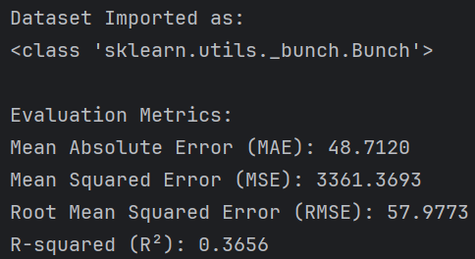*Terminal*

**Stochastic Gradient Descent**  
import numpy as np

from sklearn.datasets import load_diabetes

from sklearn.model_selection import train_test_split

from sklearn.metrics import mean_absolute_error, mean_squared_error, r2_score

diabetes = load_diabetes()

X = diabetes.data

y = diabetes.target.reshape(-1, 1)

print("Dataset Imported as:")

print(type(diabetes))

X = np.hstack([np.ones((X.shape[0], 1)), X])

X_train, X_test, y_train, y_test = train_test_split(X, y, test_size=0.2, random_state=42)

n_features = X_train.shape[1]

theta = np.zeros((n_features, 1))

learning_rate = 0.01

epochs = 1000

m = len(y_train)

for epoch in range(epochs):

for i in range(m):

random_index = np.random.randint(m)

X_sample = X_train[random_index:random_index + 1]

y_sample = y_train[random_index:random_index + 1]

prediction = np.dot(X_sample, theta)

error = prediction - y_sample

gradient = np.dot(X_sample.T, error)

theta -= learning_rate * gradient

y_pred = np.dot(X_test, theta)

mae = mean_absolute_error(y_test, y_pred)

mse = mean_squared_error(y_test, y_pred)

rmse = np.sqrt(mse)

r2 = r2_score(y_test, y_pred)

print("\nEvaluation Metrics:")

print(f"Mean Absolute Error (MAE): {mae:.4f}")

print(f"Mean Squared Error (MSE): {mse:.4f}")

print(f"Root Mean Squared Error (RMSE): {rmse:.4f}")

print(f"R-squared (R²): {r2:.4f}")

**Output**

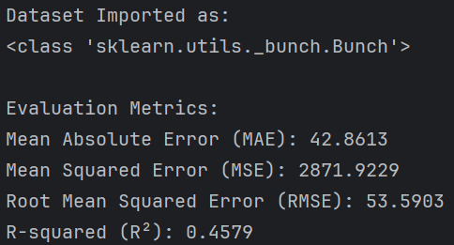*Terminal*